Balakrishna Pasam  Email : krishp.crm@gmail.com  Mobile : (818)851-7263 | 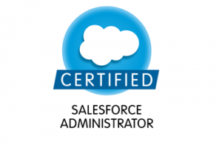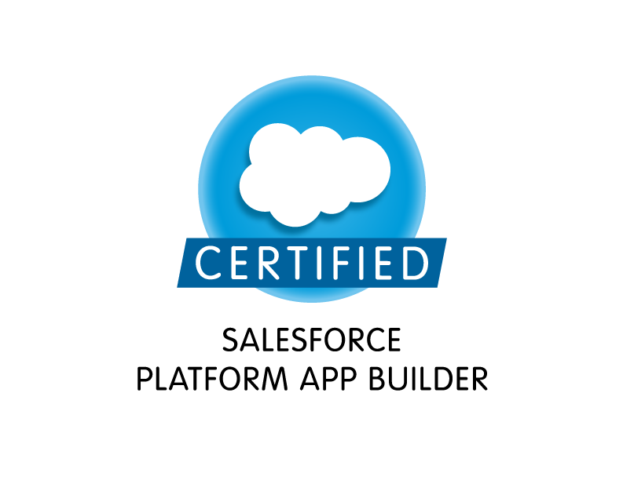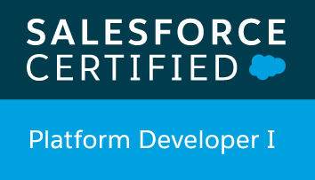

Summary
- 8+ years Information Technology industry experience and in salesforce.com. Involved in CRM road map discussions, SDLC, business requirements analysis, system design and integration, apex programming and data migration
- Implemented CRM applications for different domains including finance, telecom, banking and advertising
- Experienced in implementing end to end business flows starting from marketing, sales, order management, fulfillment, service, retention and collections
- Solid knowledge to differentiate and map the functionality specification to the standard functionality vs apex on salesforce platform
- Strong understanding with force.com MVC structure, data schema and implementing custom functionality using APEX, visualforce, Triggers
- Worked on schema design for salesforce implementation and written utility classes for common SOQL queries
- Built apex webservice classes in salesforce to perform certain business logic when other legacy systems invoke through API
- Written batch apex, scheduled classes, future classes for certain business requirements
- Implementation experience of salesforce features such as knowledge, chatter, content etc
- Followed single trigger framework to keep the code structured, maintainable and to follow the best practices
- Experience on Lightning.
- Well experienced in leveraging salesforce declarative possibilities including objects, page layouts, record types, case customizations, validation rules, workflows, formulas, reports and dashboards etc
- Experienced and succedded with several large data migrations to salesforce from other systems
- Knowledge on salesforce sharing and security model to control and maintain the instance properly including the components of OWD, sharing rules, account/opportunity teams, role and profiles
- Hands on using different version control system (SVN/GIT) to check-in APEX and other meta data components as well as using force.com migration tool to move code between the environments
- Researched and suggested several app exchange applications to serve business needs. Some of them are Eloqua, Zuora, Cornerstone LMS, Marketo, Walkme, Ingenious CTI, Docusign etc.
- Experience in web technologies like HTML, XML, CSS, JSP, JavaScript, WSDL, J-query, Tool tip & Auto Complete widget, SOAP, REST, BULK, Chatter, Streaming, METADATA API.
- Levaraged and exteneded serveral features on salesforce including service cloud, forecasting and analytics cloud on wave
- Expert in migrating data from various systems into Salesforce CRM using ETL tools such as Informatica on-demand and Cast Iron (CI) to synchronize data between Salesforce.com and web service endpoints. Data Junction (Pervasive), Excel connector and DQC.
- Worked and followed several project management methodologies including waterfall and agile
- Exllent interpersonal skills, selef motivated, good communication skills and trouble shooting capabilities

Education
Bachelor of Engineering in Computer Science, Anna University, India

Certifications
- Salesforce Certified Platform Developer
- Salesforce Certified Platform App Builder
- Salesforce Certified Administrator

Technical Skills
CRM | Salesforce.com
Salesforce Technologies | Apex, Visual Force, SFA, configurations, Triggers, SFA, Case management, Reports, Dashboards, Forcasting, Customizations, SOQL, SOSL, Sales cloud, Service cloud
Salesforce Configurations | Outbound Messages, Workflow & Approvals, Field updates, Reports, Custom Objects ,Custom settings, Custom labels and Tabs, Email Services, Role Hierarchy, Dashboards, Security Controls, App Exchange Package & Custom Application and Sandbox data loading
Force.com Tools | Apex Data loader, Force.com Apex Explorer, AJAX tool kit, Force.com Migration Tool, Force.com Excel connector
Web Technologies | J2EE, JSP, JDBC, RMI, Applet, Java Script, XML, XML Schema, HTML, Shell Scripts and Web service
Databases | Oracle 10g, SQL Server 2000/2005/2008, MS Access, MYSQL
IDE | Eclipse, sublime, visual studio
Version Control Systems | SVN,Clearcase, GIT
Data Modeling | UML , Erwin, MS Visio
Operating Systems | Windows XP/ NT/ 2000 Server/2007, Windows 2003(32 bit & 64 bit), UNIX.

Experience
Wellsfargo, Des Moines ,IA Mar 2016 – Present
Salesforce Developer

Wells Fargo, which provides Banking, Investing and Loan services to their customers. Salesforce.com developed and implemented a custom Salesforce CRM solution for Wells Fargo Core montage application that integrated and replaced its fragmented system on premise software. This project was developed to maintain Accounts, Contacts, Opportunities, Cases, Solutions, dashboard, including all contact with Wells Fargo and relevant financial information that advisors could access easily in one place. Salesforce.com mobile CRM solution that gave advisors secures access to client data on Blackberries.

Responsibilities:
- Worked closely with product managers to understand the use cases, business requirements and further converted them the technical specifications
- Designed technical flows for the business requirements and indetailed mapping to salesforce technical possibilities by following bsest practices
- Conducted new initiatives peer review for both design and code using JIRA and stash respectively
- Created the APEX classes, custom controllers, controller extensions, visualforce pages and APEX Triggers to develop the custom functionality and meet the business requirements.
- Implemented fancy and good looking user interface using javascript and css on top of visualforce/
- Writen Lightning components for an Acount, contact .
- A well structured single trigger framework followed to avoid getting into recursive loops and to avoid hitting governor limits
- Installed app exchange applications including Eloqua, Zuora, docusign, Ingenius, Forseva to leverage built in functionality and to serve business immediately
- Salesforce declarative functionality leveraged and customized such as objects, page layouts, record types, workflows, validation rules, formula fields, reports, dashboards and chatter etc
- Implmented CTI to serve both sales and service purposes for both inbound and outbound calls
- Written scheduled classes to perform the data manipulations on nightly or weekly bases using the batch apex
- Written APEX test classes for unit testing inclused data testing, postivte/negative scenarios and assert checks with the minimum code ocverage of 85%
- Created custom apex web services to automate the order creation and lead deupe with the call invocation from outside of salesforce
- Used GIT for version controlling system and used source tree as an UI to perform the code push/pull operations
- Used Sublime, mavensmate, GIT, force.com migration tool and Jenkins combination along with ant script to develop code, maintain the versioning and moving code around the environments
- Defined sharing and visbility along with roles, profiles, sharing rules and written apex based sharing in few scenraios where it ‘s required to add sharing and team memebers
- Implmented services cloud for both service and rention purposes along with knowledge rool out which will be self exploitary to the reps
- Created test scenarios on Sandbox environment, created packages and moved it between Sandboxes and Production environments to place final implementations.
- Involved in migrating data into Salesforce application using apex data loader through CSV files. Installed and configured apex data loader.
- Used SOQL & SOSL for data manipulation needs of the application using platform database objects.
- Extracted the data from Salesforce.com application into the external databases (Oracle 11g) for generating large data reports using the Informatica on Demand.
- Provided post-implementation support to assist end users in creating reports, dashboards and certain Administration tasks including creating and maintaining user profiles and privileges.
- Implemented security and sharing rules at object, field, and record level for different users at different levels of organization. Also created various profiles and configured the permissions based on the organizational hierarchy.
- Executed various levels of Unit, Integration, User Acceptance and Operational Acceptance testing using test cases to prove that system conform to specifications of business and quality requirements.
- Participated in Weekly Change control meetings and performed application and global impact analysis. DAP Directory integration​n for Salesforce​.com.
- Worked on SFDC, CRM, SFA and Billing Modules (Sales Process Automation, Lead and Marketing Automation, Mass Marketing Automation, Customer Care ,Accounts Receivables, Credit Limit process, Collections, Rating ,Billing, Discounts ,Catalogues, Invoicing, Reporting).

Environment: Saleforce.com platform, Apex Language, Visual Force (Pages, Component & Controllers), Pages,
Data Loader, HTML, Java Script, Workflow & Approvals, Reports, Custom Objects, Custom Tabs, Email Services,
Marketo configuration and customization, Security Controls, Sandbox data loading, Eclipse IDE Plug-in, Windows

Citrix Systems Fort Lauderdale FL Oct 2014 – Mar 2016 Salesforce Developer

Citrix provides a complete and integrated portfolio of Workspace-as-a-Service, application delivery, virtualization, mobility, network delivery and file sharing solutions that enables IT to ensure critical systems are securely available to users via the cloud or on-premise and across any device or platform.

Its core product is GoTo Meeting.

Responsibilities:
- Interacted with various business user groups to gather the requirements and documented the requirements.
- Involved in Salesforce.com Application Setup activities and customized the apps to match the functional needs of the organization.
- Designed and developed SFA based Application on Force.com Platform in Salesforce.com environment with Apex programming language at backend and Visualforce pages as user interface.
- Worked on Salesforce Automation (SFA), Opportunity Management, Account and Contact Management, Data Quality Management, Approvals and Workflow.
- Used Force.com IDE for creating, modifying, testing, and deploying Force.com Application.
- Worked with various Salesforce.com objects like Accounts, Contacts, Leads, Campaigns, Reports, and Opportunities.
- Developed various Custom Objects, Tabs, Entity-Relationship data model, validation rules, Components and Visualforce Pages.
- Created workflow rules and defined related tasks, time triggered tasks, email alerts, field updates to implement business logic.
- Created templates, approval processes, approval page layouts and defined approval actions on them to automate the processes.
- Developed Apex Classes, Controller Classes and Apex Triggers for various functional needs in the application.
- Used SOQL & SOSL with in Governor Limits for data manipulation needs of the application using Force.com Explorer.
- Extracted the data from Salesforce.com application into the external databases (Oracle 10g) for generating large data reports using the Informatica OnDemand.
- Involved in the Data Transformation and Data Cleansing activities while transferring the data to the external system using Informatica OnDemand.
- Created users, roles, public groups and implemented role hierarchies, sharing rules and record level permissions to provide shared access among different users.
- Created profiles and implemented Object and field level security to hide critical information on the profile users.
- Created various Reports (summary reports, matrix reports, pie charts, dashboards and graphics) and Report Folders to assist managers to better utilize Salesforce as a sales tool and configured various Reports for different user profiles based on the organization’s need.
Environment: Salesforce.com platform, Apex Language, Visualforce Pages, Data Loader, Workflow & Approvals, Email Services, Reports, Dashboards, Custom Objects, Custom Tabs, Eclipse IDE Plug-in, Salesforce Sandbox, HTML, Java Script, Windows XP.

Abbott, Santa Clara, CA July 2013 - Oct 2014
Salesforce Developer
OneStep is intended to implement a single, global system for the ADC (Abbott Diabetic Care) Customer
Service Organization to manage customer call registration & tracking, trouble shoot customer complaints, and provide an interface with the product complaints investigation and reporting applications. This includes Case Management, Complaint Investigation and Evaluation, Contact Management, Issue Management, Order Management, Workflow Management, Asset, Warranty System, Security, Reports and Dash boards. An ETL (Informatica) tool performed data loading for from external system to OneStep and OneStep to external system.

Responsibilities
- Worked on modifying various managed packages which includes Email Alerts to the Company.
- Developed a Visual Force Email Template which notifies the clients once it satisfies the business logic and when criteria are met. This also involved generating Client Logo and attaching to the template.
- Implemented various Apex classes, Triggers, Batch & Schedulable classes and also the Future method for handling huge data transactions or Bulk operations.
- Also worked and developed various Portal based requirements for the end clients to view the data.
- Worked with various Salesforce.com objects like Accounts, Contacts, Leads, Campaigns, Reports, Dashboards.
- Created various Test Classes and deployed into Production which satisfies the code coverage.
- Worked on Q-tip plugin for Tool Tip and Auto Complete to implement suggestion functionality on Staff Portal.
- Involved in client based meetings to fulfill the end requirement using BMC Remedy Force increasing the sales process.
- Worked on various Salesforce Administrations tasks like Reports, Dashboards, Custom Workflow rules, Field Update, Email Templates, Field level & Object level Securities, Roles, Profiles, Validation Rules, Formula fields etc.
- Used custom tools like Apex data loader & Jitter Bit for the handling the data for insertion, update & deletion.
- Worked back & forth with the SQL Database & Crystal Report developing tools for manipulating the data & gathering reports.
- Created and Customized the Dashboards to the track usage for productivity and performance of business centers and their sales teams.
- Performed various modifications on the existing code inside Salesforce & followed the governor limits before deployment into Production.
- Created the Technical Document & the Test Case document for the in-house Salesforce Administrator to keep a track.
- Worked with team members for full-cycle projects, such as developers, to complete consulting projects on time, and deliver outstanding consulting services to Salesforce.com clients.

Environment: Saleforce.com platform, Apex Language, Visual Force (Pages, Component & Controllers), Pages, Data Loader, HTML, Java Script, Workflow & Approvals, Reports, Custom Objects, Custom Tabs, Email Services, Sandbox data loading, Eclipse IDE Plug-in, Informatica on Demand, Windows XP

Tax Credit Co, Los Angeles, CA Aug 2011 – Jun 2013

Salesforce Developer

Tax Credit Co. is a national provider of tax incentive consulting, administration and technology for their clients. Tax Credit Co. is one of the industry leader in obtaining state and federal tax incentives, including state and federal research and development tax credits, state enterprise zone tax credits, national hiring incentives such as the Work Opportunity Tax Credit and other state and federal programs.Salesforce.com CRM has accomplished their needs of Sales and service services by Salesfoce custom and standard technical services. This project was implemented a custom Salesforce CRM solution and integrated and replaced its fragmented system of on-premise software.

Responsibilities:
- Salesforce implementation using Account/ contact, Opportunity, Case, Activity, Interaction Log, Email/ Mass Email, Reports and Dashboards.
- Gathering requirements, functional and technical, for several projects and involved in the design of prototypes.
- Customer business process understanding of third party management and functional mapping of Salesforce modules with the business process.
- Used Data Loader for insert, update, and bulk import or export of data from (SFDC) Salesforce.com objects. Migrated data from SQL Database to Salesforce using Command Line Data Loader.
- Designed, developed and deployed Apex Classes, Controller Extension Classes to support Visualforce Pages development, Test Classes for Unit testing and Apex Triggers for various functional needs in the application.
- Used SOQL & SOSL for data manipulation needs of the application using platform database objects.
- Development of Triggers and APEX Classes on both Standard and Custom objects
- Created Custom buttons, Record types, page layouts, Profiles, Custom Setting and Assignment rules.
- Used Eclipse with Force.com plug-in for code backup, components validation and deployment to support development, QA, UAT and Production rollouts
- Performed POC for Customized UI/Screen navigation requirement for the business
- Worked with Salesforce premier support to resolve technical challenges & unknown issues occurred specific to that organization
- Developed Salesforce.com custom application using Apex, Visual force and AppExchange.
- Created users, roles, public groups and implemented role hierarchies, sharing rules and record level permissions to provide shared access among different users.
- Created workflow rules and defined related tasks, email alerts and field updates.
- Implemented rest based web service apex classes in salesforce to allow SAP system for accessing the specific functionality flow in Salesforce.com.
- Created various Reports and Report folders to assist managers to better utilize Salesforce as a sales tool and configured various Reports for different user profiles based on the needs of the organization.
- Created custom Dashboards for manager’s home page and gave accessibility to dashboards for authorized people.
- Conducted GAP Analysis and enhanced business process by integration.
- Implemented pick lists, dependent pick lists, lookups, master detail relationships, validation and formula fields to the custom objects.

Environment: Saleforce.com platform, Apex Language, Visual Force (Pages, Component & Controllers), Pages, Data Loader, HTML, Java Script, Workflow & Approvals, Reports, Custom Objects, Custom Tabs, Email Services, Sandbox data loading, Eclipse IDE Plug-in, Informatica on Demand, Windows XP

Quinnox Consultancy Services Ltd, Pune, India Jun 2009 – July 2011

Salesforce Developer

Quinox is one of the leading organizations in Software development, and offering Home, Life, Business, Recreational and Financial Insurance services software development to the customers. This project was developed to maintain Accounts, Contacts, Opportunities, Cases, Solutions, Products, opportunities and case management.

Responsibilities:
- Involved in creating Gap Analysis document identifying the data, business process and work flows of the organization with respect to SalesForce.com implementation.
- Performed present Lead, Enrollment and Retention to forecast Trend analysis
- Helped increase Spend to Lead generation.
- Gathering requirements, functional and technical, for several projects and involved in the design of prototypes.
- Queried databases, performed data extract requests, list pulls and Statistical Analysis.
- Defined, Designed and Developed reports to support marketing activities.
- Maintained the Requirements Traceability Matrix (RTM) across the deliverables of a project.
- Collected and Reported on external sources of data to drive business decisions
- Verified Analysis and Report accuracy with minute detail
- Created offline surveys and data collection forms.
- Migrated data from Oracle DB to Sales force using DB Sync.
- Developed various Custom Objects, Reports, Tabs, Components and Visual force Pages and Controllers for different user profiles based on the need in the organization.
- Implemented ETL jobs between Salesforce.com and internal legacy systems using Informatica
- Worked on sharing rules by setting an Organization-wide default sharing access level, and then grant additional access based on the requirements.
- Unit test classes written prior to the actual development based on the functionality for the quality.
- User Interface Configured Marketing Campaign Management and Hierarchies, Campaign Influence, Lead Conversion, Assignment rules, as well as Case Management Process.
- Prepared pictorial Use Cases Diagrams and High-level Process Flow Diagrams using MS Visio and MS Word. In addition, have strong exposure and ability to analyses Activity Diagrams, Sequence Diagrams.
- Used Data Loader for insert, update, and bulk import or export of data from (SFDC) Salesforce.com subjects. Used it to read, extract and load data from comma separated values (CSV) files.
- Written nightly batch jobs to perform time based criteria met asynchronous data updates

Environment: Saleforce.com platform, MS Visio, MS project, Standard and Custom Objects, Validation rules, Workflow & Approvals, Record types, Reports, Apex Language, Visual Force (Pages, Component & Controllers),

